FPT UNIVERSITY, HO CHI MINH CITY
COURSE: MCP201
PROJECT REPORT
DESIGN AND DEVELOPMENT
OF AN AUTOMATIC PLANT WATERING SYSTEM
USING STM32 BLUE PILL
Automatic Plant Watering System Based on STM32 Blue Pill

Course: | MCP201
Instructor: | VinhPT30
Project team: | Group 3
Members / Student IDs: | Hoàng Anh Tuấn — SE205206
 | Nguyễn Cao Khánh — SE205076
 | Nguyễn Minh Khôi — SE201660
 | Ngô Trần Vũ Khang — DE200076
HO CHI MINH CITY, 2026

TABLE OF CONTENTS

LIST OF FIGURES, TABLES, AND ABBREVIATIONS 4
List of Figures 4
List of Tables 4
List of Abbreviations 4
CHAPTER 1. INTRODUCTION 5
1.1. Background and Practical Needs 5
1.2. Project Objectives 5
1.3. Subject and Scope 5
1.4. Overall Solution and System Functions 6
1.5. Implementation Method 6
CHAPTER 2. THEORETICAL BACKGROUND 7
2.1. STM32 Blue Pill Microcontroller 7
2.2. Soil Moisture Sensor 7
2.3. DHT11 Temperature and Humidity Sensor 8
2.4. DS3231 Real-Time Clock 8
2.5. LCD 1602 with I²C Interface 9
2.6. 5 V Relay and Submersible Pump 9
2.7. Control Buttons and Status LED 9
2.8. Two-Threshold Watering Principle 9
2.9. Converting ADC Readings to Percentages 10
2.10. Additional Watering Modes 10
CHAPTER 3. SYSTEM DESIGN AND PROGRAMMING 11
3.1. Design Requirements 11
3.2. Pin Assignment and Hardware Connections 13
3.3. Peripheral Initialization and Controller Configuration 14
3.4. Soil Moisture Acquisition and Processing 15
3.5. DHT11, DS3231, and LCD Interface Processing 17
3.6. Pump Control Algorithm 19
3.6.1. Configuration Mechanism 20
3.7. Flow Diagram 20
3.8. Stability and Protection Mechanisms 21
3.8.1. Watering Runtime Limit 21
3.8.2. Watchdog and I²C Recovery 21
3.8.3. Saving Parameters to Flash 21
CHAPTER 4. TESTING AND EVALUATION 23
4.1. Test Objectives and Methodology 23
4.2. Experimental Data and Photographs 24
4.3. Evaluation of Experimental Results 25
CHAPTER 5. CONCLUSIONS AND FUTURE DEVELOPMENT 26
5.1. Conclusions 26
5.2. Limitations and Challenges 26
5.3. Future Development 26
REFERENCES 27

LIST OF FIGURES, TABLES, AND ABBREVIATIONS

List of Figures
Figure 1.1 Overall block diagram of the plant watering system
Figure 2.1 DHT11, DS3231, and soil moisture sensors
Figure 3.1 Electrical schematic of the automatic plant watering system
Figure 3.2 Actual circuit assembly
Figure 3.3 ADC1, I²C1, and TIM2 peripheral configuration
Figure 3.4 Soil moisture processing and conversion code
Figure 3.5 DHT11, RTC, and LCD processing code
Figure 3.6 Pump control algorithm
Figure 3.7 Configuration storage and error-handling code
Figure 4.1 Automatic plant watering system prototype
Figure 4.2 Dry soil condition and running pump
Figure 4.3 Adequately moist soil or scheduled watering

List of Tables
Table 2.1 Component functions
Table 3.1 Hardware pin assignments
Table 4.1 Test scenarios
Table 4.2 Experimental data sheet

List of Abbreviations
Abbreviation | Definition
ADC | Analog-to-Digital Converter
GPIO | General-Purpose Input/Output
I²C | Inter-Integrated Circuit – two-wire communication bus
RTC | Real-Time Clock
LCD | Liquid Crystal Display
HAL | Hardware Abstraction Layer
IWDG | Independent Watchdog

CHAPTER 1. INTRODUCTION

1.1. Background and Practical Needs
Plant care in homes, classrooms, or practice areas often depends on manual observation and watering. When the caretaker is absent, water may not be supplied at the appropriate time or according to the current soil moisture level. A small-scale automatic watering system can reduce repetitive operations and help maintain more consistent plant care conditions.
In response to this need, the team developed a model using the STM32 Blue Pill board as the central controller. A soil moisture sensor provides information for deciding when watering is necessary. The DS3231 real-time clock supports scheduled watering, while the DHT11 measures ambient temperature and humidity for environmental monitoring. The LCD 1602 displays system information, and a 5 V relay switches the power supplied to the submersible pump. This model is intended for learning and embedded-systems practice rather than industrial irrigation.

1.2. Project Objectives
- Read the analog signal from the soil moisture sensor, calibrate the dry and wet reference values, and display the converted moisture percentage.
- Automatically activate the pump when the soil is dry and stop it once the configured moisture threshold is reached; reduce frequent switching through two separate thresholds.
- Enable watering according to a schedule maintained by the RTC, as well as manual pump activation for a specified duration.
- Read DHT11 measurements, display information on the LCD 1602, and save configuration parameters for use after a restart.
- Implement risk-reduction measures such as limiting automatic pump runtime, recovering I²C communication, and using a watchdog.

1.3. Subject and Scope
The subject of this project is an automatic plant watering system based on the STM32 Blue Pill microcontroller board, integrating a soil moisture sensor, a DHT11 temperature and humidity sensor, a DS3231 RTC module, an I²C LCD 1602, a relay, and a submersible pump.
The scope focuses on the design, assembly, and programming of a small-scale automatic watering system. The system can monitor soil moisture, automatically switch the pump on or off according to configured thresholds, water on a schedule, and accept manual commands. Environmental measurements and operating states are displayed on the LCD for convenient monitoring.
The project primarily serves educational purposes and the practical application of embedded-systems knowledge; it is not intended for large-scale agricultural deployment.

1.4. Overall Solution and System Functions
The system is designed with three main watering modes:
(1) Soil-moisture-based automatic watering: the pump starts when the soil moisture falls below the start threshold and stops when the stop threshold is reached.
(2) Scheduled watering: the system uses time information from the DS3231 RTC to activate the pump at a configured time.
(3) Manual watering: the user presses the PUMP button to start or cancel a timed watering request.
The STM32 microcontroller processes watering requests from these modes and controls the relay to operate the pump. The DHT11 measures ambient temperature and humidity for display on the LCD 1602. These values are for environmental monitoring and do not directly determine the pump state.

Input block | Processing / communication block | Output block
Soil moisture sensor (AO)  DHT11 (DATA)  DS3231 (I²C)  4 push buttons | STM32 Blue Pill  ADC1 + GPIO + TIM2 + I²C1  Threshold/scheduling logic + Flash | 5 V relay → submersible pump  LCD 1602 I²C  Status LED

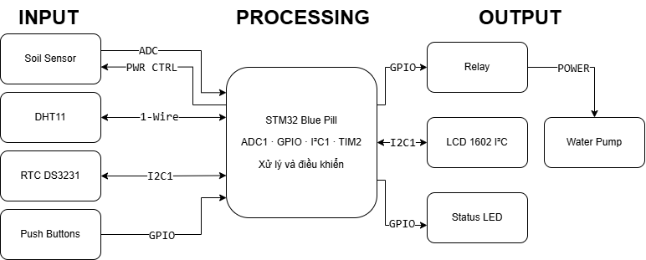
Figure 1.1 – Overall block diagram of the plant watering system

1.5. Implementation Method
- Study the functions of the components and ADC, GPIO, I²C, and DHT11 communication; consult official technical references [1]–[4].
- Develop the control flowchart, assign I/O pins, and configure peripherals in STM32CubeIDE.
- Program the functional blocks separately, then integrate sensor acquisition, display, scheduling, and relay control.
- Test dry/wet watering, scheduling, the pump button, sensor disconnection, and configuration storage; capture photographs and record results in Chapter 4.
The report is organized into five chapters: introduction, theoretical background, system design and programming, testing, and conclusions and future development.

CHAPTER 2. THEORETICAL BACKGROUND

2.1. STM32 Blue Pill Microcontroller
The Blue Pill is a development board based on an STM32F103 microcontroller from the STM32F1 family, featuring an ARM Cortex-M3 core and peripherals such as ADC1, I²C1, TIM2, GPIO, and Flash. The STM32F103C8 supports a CPU clock of up to 72 MHz, a 12-bit ADC, and several integrated communication interfaces [1], [2]. In this system, the PLL uses the HSE clock source to generate 72 MHz, while TIM2 is configured as a 1 MHz counter for microsecond-level timing.
Component | Role in the system
ADC1 channel 2 | Digitizes the soil sensor AO signal through PA2.
I²C1, 100 kHz | Communicates with the DS3231 and LCD via SCL/SDA.
TIM2, 1 MHz | Provides microsecond-level timing for DHT11 frame acquisition.
GPIO | Controls the relay and soil sensor power, reads buttons, and blinks the LED.
Flash / IWDG | Stores persistent settings / restarts the MCU if the firmware hangs.
Table 2.1. Functions of the system components.

2.2. Soil Moisture Sensor
The system uses a resistive soil moisture sensor with two electrodes and a module providing an analog AO output. Electrical conductivity between the electrodes varies with soil moisture and soil properties; therefore, the calibrated ADC output represents relative moisture rather than a standardized volumetric water content measurement.
The firmware enables power to the sensor through PB0 for approximately 15 ms before measurement, acquires and averages 16 ADC samples, and then switches off the sensor power. Periodic powering reduces the time for which voltage is continuously applied to the metal electrodes and helps limit corrosion. The measurement interval is designed to be 500 ms.

2.3. DHT11 Temperature and Humidity Sensor
The DHT11 transmits temperature and ambient humidity data through a one-wire digital interface. The microcontroller sends a start signal, waits for the sensor response, and receives 40 data bits containing humidity, temperature, and checksum bytes. In the firmware, DHT11_Read() uses TIM2 to measure bit timing and verifies the checksum before accepting a reading. Measurements are updated every two seconds, consistent with the sensor’s relatively slow sampling rate [4].
The current firmware uses the integer bytes only and displays the readings for environmental monitoring; air temperature and humidity do not adjust pump runtime. When data is invalid, the LCD displays “--” instead of presenting an unverified new measurement.

2.4. DS3231 Real-Time Clock
The DS3231 is an I²C RTC that maintains seconds, minutes, hours, days, months, and years and provides a backup battery connection. A properly installed backup battery enables the clock to maintain time when the primary supply is disconnected [3]. The firmware communicates using the 7-bit I²C address 0x68, reads seven time registers beginning at 0x00, and converts BCD values to decimal. Note that the source code was written to support both the DS1307 and DS3231: rtc_read() checks bit 7 of the seconds register (the DS1307 CH bit). On the DS3231, this bit is always zero, so the halted flag is ineffective, and the DS3231 oscillator-stop flag (OSF) is not currently checked.
During startup, the firmware checks the RTC time and may initialize it using the compilation time if the stored data is invalid. The compilation time can differ from the actual operating time, so the clock must be set and verified before scheduled watering is used. The program periodically compares hours and minutes and prevents repeated triggering within the same minute.
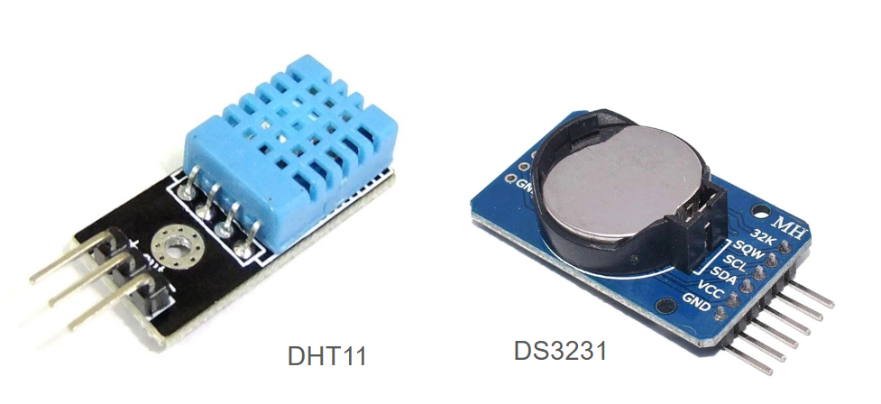
Figure 2.1 – DHT11, DS3231, and soil moisture sensors

2.5. LCD 1602 with I²C Interface
The LCD 1602 displays two rows of up to 16 characters each. The I²C interface module commonly uses a PCF8574 I/O expander, allowing the STM32 to control the display over SCL and SDA rather than multiple parallel GPIO lines [4]. The firmware probes addresses 0x27 and 0x3F in sequence, initializes the LCD in 4-bit mode, and sends display commands over I²C1 at 100 kHz.
The main display alternates among temperature/ambient humidity, clock/soil moisture/pump state, watering schedule/thresholds, and calibrated ADC values. Each view changes approximately every three seconds. Menu pages allow users to modify configuration parameters.

2.6. 5 V Relay and Submersible Pump
The relay acts as an electrical switch for the separate power supply branch feeding the pump. The STM32 provides a logic control signal only; it does not directly supply motor current. In the code, RELAY_ON_LEVEL defaults to GPIO_PIN_SET, meaning the firmware assumes a HIGH-level-triggered relay module. The team must verify the actual module characteristics and jumper settings to avoid inverted operation.
Pump power must be selected according to the motor’s rated voltage and current. The relay switches the supply via COM and NO or NC contacts, depending on the wiring. Because the STM32 uses 3.3 V logic and the relay module uses a 5 V supply, compatible control levels and measures to reduce motor-induced electrical noise are required.

2.7. Control Buttons and Status LED
The system uses four buttons—MENU, UP, DOWN, and PUMP—connected to PB12, PB13, PB14, and PB15, respectively. These pins use internal pull-up resistors, the buttons connect to GND, and the software applies a 30 ms debounce interval. The LED on PC13 indicates program activity.

2.8. Two-Threshold Watering Principle
Using a single threshold to switch the pump on and off could make the relay toggle repeatedly when the sensor reading fluctuates near that threshold. The firmware therefore uses two thresholds: start to begin watering when moisture is low and stop to end watering when moisture is sufficient. This approach is called hysteresis control.
AUTO: if soil < start → request pump ON
if soil ≥ stop → end the automatic request
if runtime ≥ 60 s → stop and cool down for 5 minutes

The source-code defaults are start = 30% and stop = 60%, with automatic mode enabled. If an automatic watering cycle reaches the 60-second limit without meeting the stop threshold, the system enters a 300-second cooldown before another automatic watering cycle is allowed. This five-minute cooldown occurs only after reaching the runtime limit, not after every pump shutdown.

2.9. Converting ADC Readings to Percentages
The firmware stores two calibration values: dry, the ADC reading in dry conditions (default 4000), and wet, the reading in wet conditions (default 1500). After reading raw, the system calculates relative soil moisture as follows:
soil_percent = clamp( (raw - dry) × 100 / (wet - dry), 0, 100 )

For example, with dry = 4000, wet = 1500, and raw = 2750, the formula produces 50%. This is a calculation example, not an experimental measurement. The formula supports reversed signal polarity as long as wet differs from dry; when the two calibration points are identical, the function returns 0%.

2.10. Additional Watering Modes
The default watering schedule is enabled at 07:00 for ten seconds. Pressing PUMP also starts a timed pumping request with a default duration of ten seconds; pressing the button again during a timed request cancels it. Scheduled and manual pumping share the pump_timed variable, while sensor-based watering uses auto_run. The relay turns on when either pump_timed or auto_run is true, so disabling automatic mode does not disable every possible pumping request.

CHAPTER 3. SYSTEM DESIGN AND PROGRAMMING

3.1. Design Requirements
The design follows a sensing–processing–actuation architecture. The STM32 updates soil moisture periodically, acquires DHT11 and RTC data at their respective intervals, and determines output states during each iteration of the main loop. Timers use HAL_GetTick() to manage millisecond timestamps, avoiding a single long blocking delay for the entire program. The team provides the complete program source in main.c [8].
Data flow | Description
Soil sensor → ADC1 → STM32 | Reads 16 samples and normalizes using two calibration points.
DHT11 → GPIO/TIM2 | Receives ambient temperature/humidity and verifies the checksum.
RTC ↔ I²C1 ↔ STM32 | Obtains real time for watering schedule comparisons.
STM32 ↔ I²C1 ↔ LCD | Displays information and switches configuration pages.
STM32 → relay → pump | Switches motor power when watering is requested.

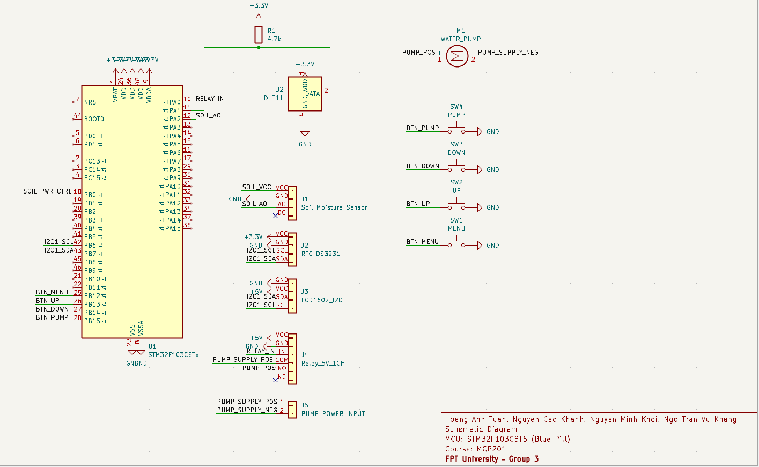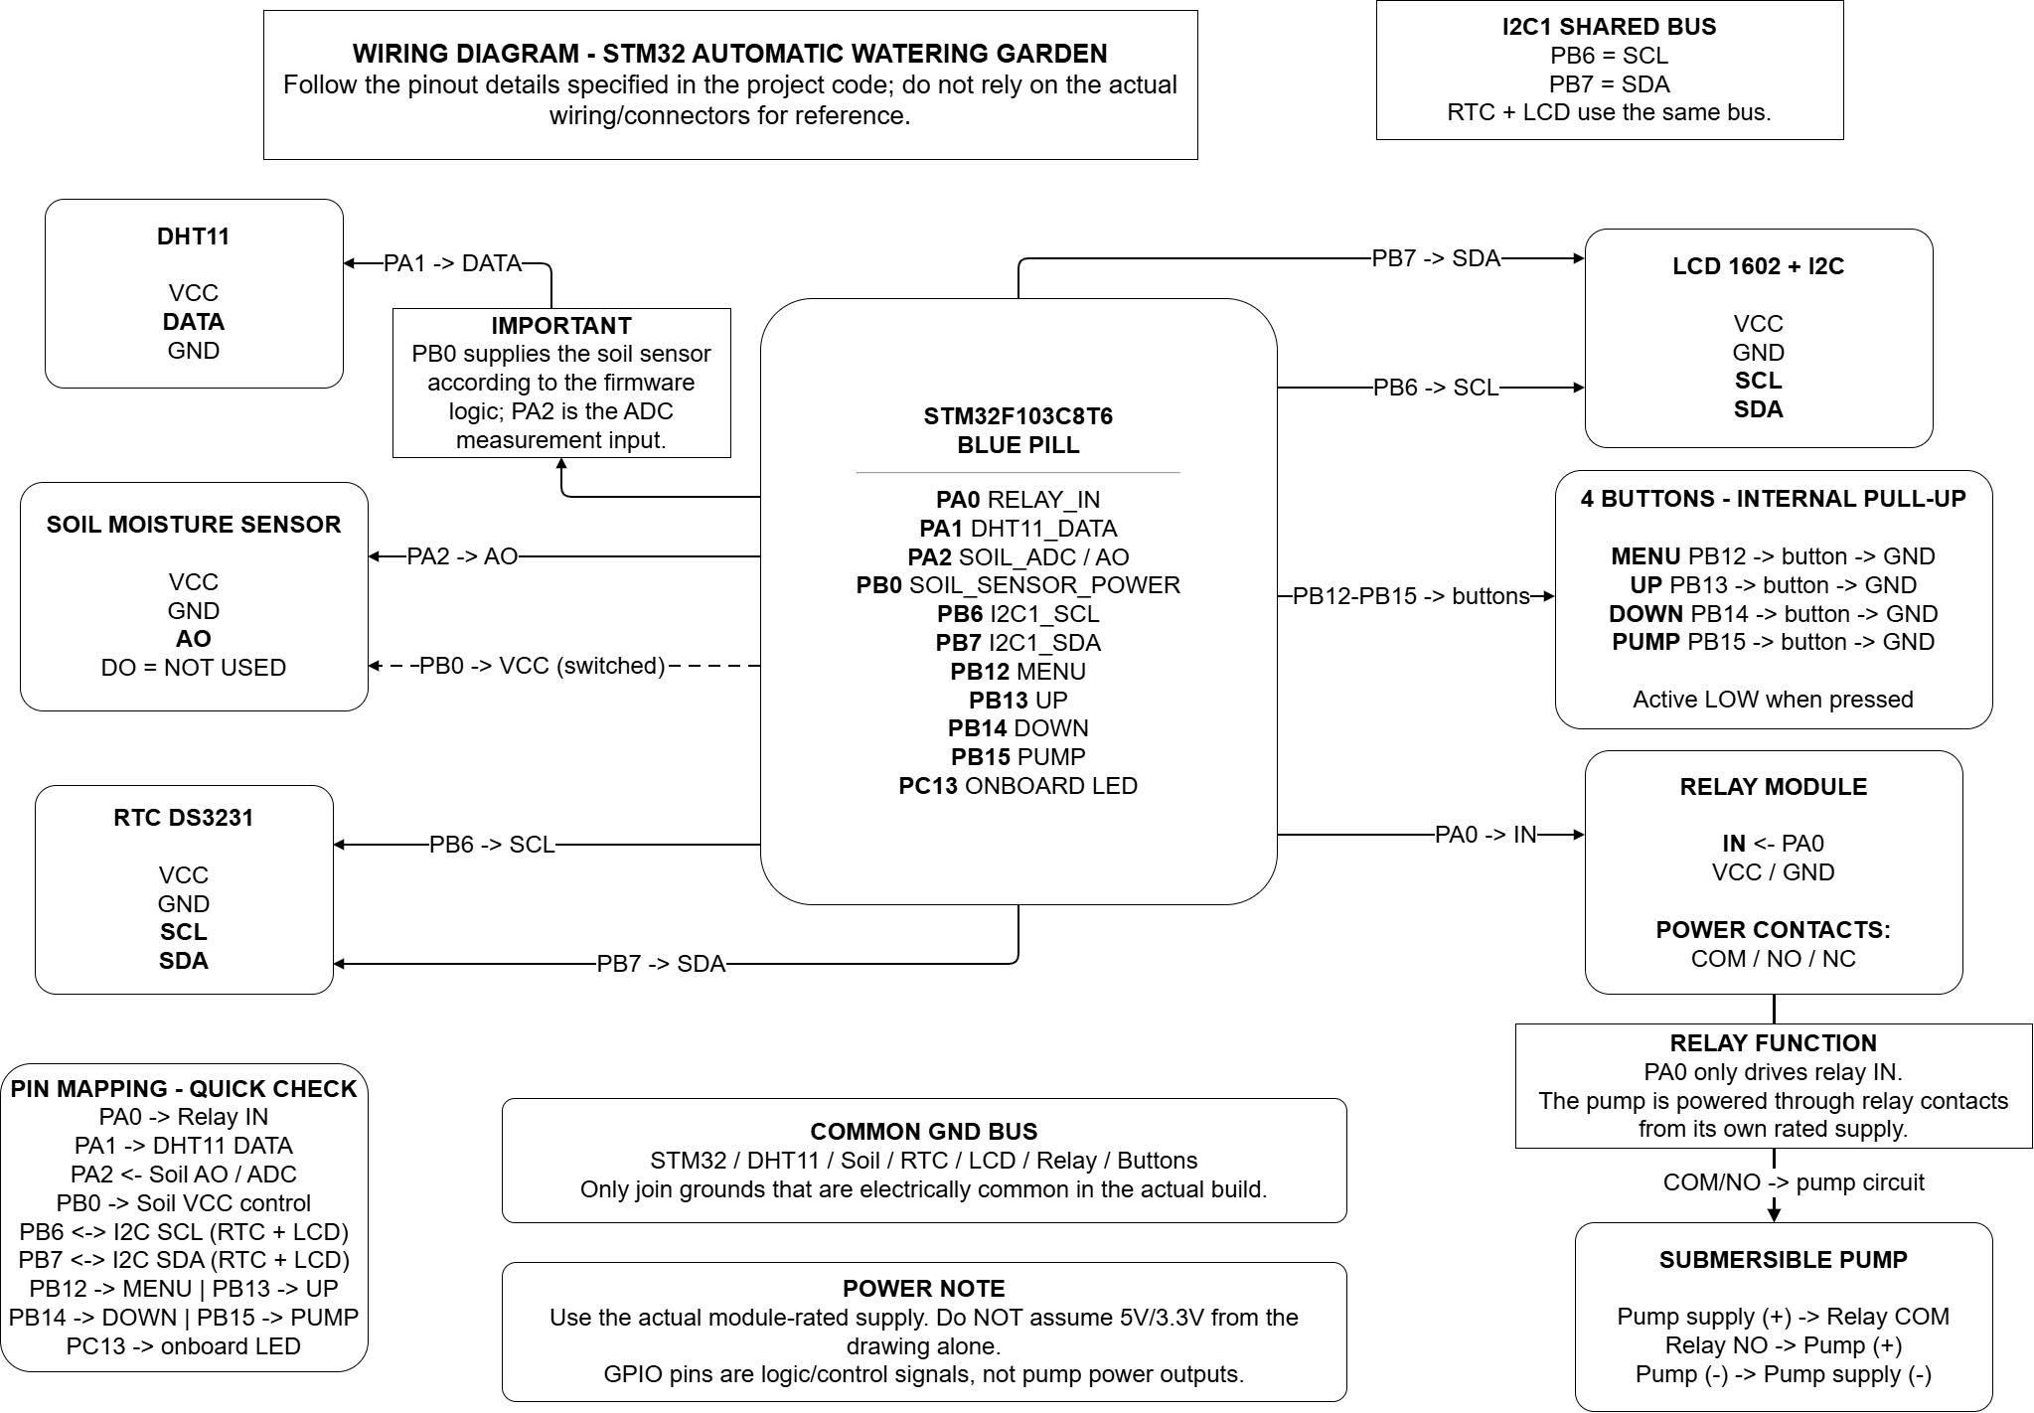
Figure 3.1 – Electrical schematic of the automatic plant watering system
The schematic shows signal connections among the STM32 Blue Pill, sensors, RTC, LCD, and pump-control relay. Power for the microcontroller, relay module, and motor is supplied according to their respective voltage requirements. PB6 and PB7 form the shared I²C1 bus for the DS3231 and LCD, while the relay contacts switch the pump’s separate power supply.

3.2. Pin Assignment and Hardware Connections
Device / signal | STM32 pin or configuration | Notes
Soil moisture sensor AO | PA2 – ADC1 Channel 2 | Sensor power is switched via PB0; DO is unused.
Soil sensor power | PB0 – GPIO output | Drive HIGH 15 ms before sampling.
DS3231 RTC | I²C1 – SCL PB6, SDA PB7 | Address 0x68 (7-bit).
LCD 1602 + I²C | I²C1 – chung PB6/PB7 | Probe address 0x27, then 0x3F.
Single-channel relay | PA0 – GPIO Output | Relay control; HIGH-level triggering assumed in the firmware.
DHT11 DATA | PA1 – GPIO Input/Output | Transmits and receives DHT11 data.
MENU / UP / DOWN / PUMP | PB12 / PB13 / PB14 / PB15 | Four buttons connect to GND and use internal pull-ups.
Status LED | PC13 – GPIO Output | Status LED on the STM32 Blue Pill.

Table 3.1. Pin assignments for components connected to the STM32 Blue Pill. The pins are determined from the project configuration and control firmware; the DS3231 RTC and LCD 1602 share I²C1 on PB6/PB7.
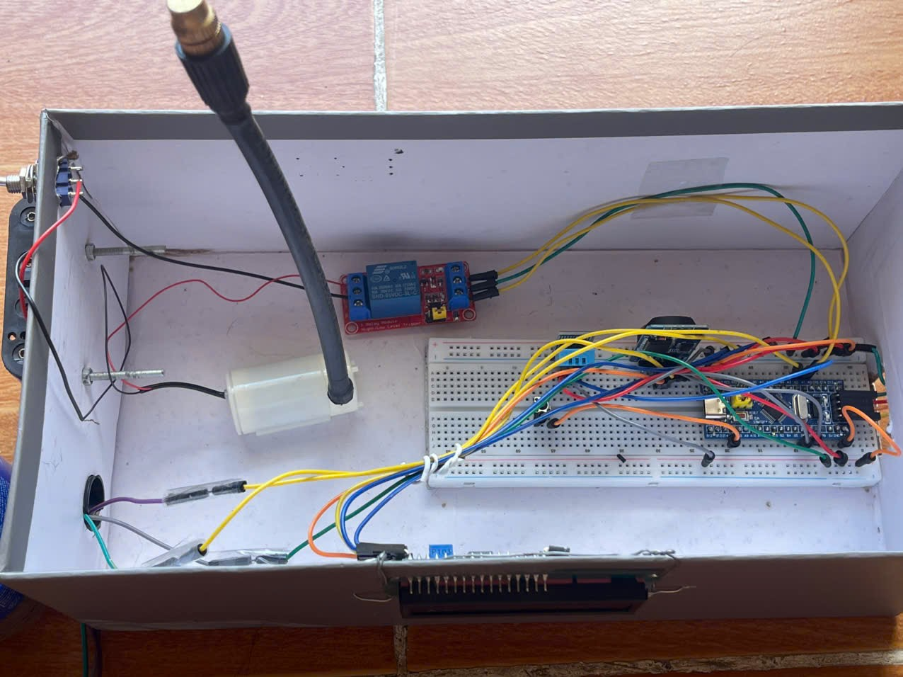
Figure 3.2 – Photograph of the actual circuit assembly

In the design, the voltage at ADC input PA2 must remain within the limits permitted by the STM32. Modules powered from 5 V must be checked for compatibility with the 3.3 V microcontroller signal levels, particularly on the I²C bus and the relay-control input. The pump is supplied through the relay contacts at the motor’s rated voltage.

3.3. Peripheral Initialization and Controller Configuration
The firmware uses HAL_Init(), SystemClock_Config(), and peripheral initialization functions to configure the controller. With HSE and a PLL multiplier of ×9, the system clock reaches 72 MHz. APB1 is divided by two, while APB2 runs at the system clock frequency. These settings are configured in STM32CubeIDE according to firmware requirements [1], [2], [7].
ADC1 operates on channel 2 in single-conversion, software-triggered mode. After initial configuration, the code changes the sampling time to 239.5 cycles to accommodate the relatively high output impedance of the sensor. HAL_ADCEx_Calibration_Start() is called before the main loop. Increasing the sampling interval can improve ADC stability with a high-impedance signal source [6].
I²C1 operates at 100 kHz with 7-bit addressing; TIM2 uses a prescaler of 71 to achieve 1 µs per timer tick. The DHT11 interface uses this counter to capture short pulse widths. The relay and LED GPIOs are configured as outputs, while button pins are configured as pull-up inputs.
MX_GPIO_Init();
MX_ADC1_Init();
MX_I2C1_Init();
MX_TIM2_Init();
HAL_TIM_Base_Start(&htim2);
HAL_ADCEx_Calibration_Start(&hadc1);

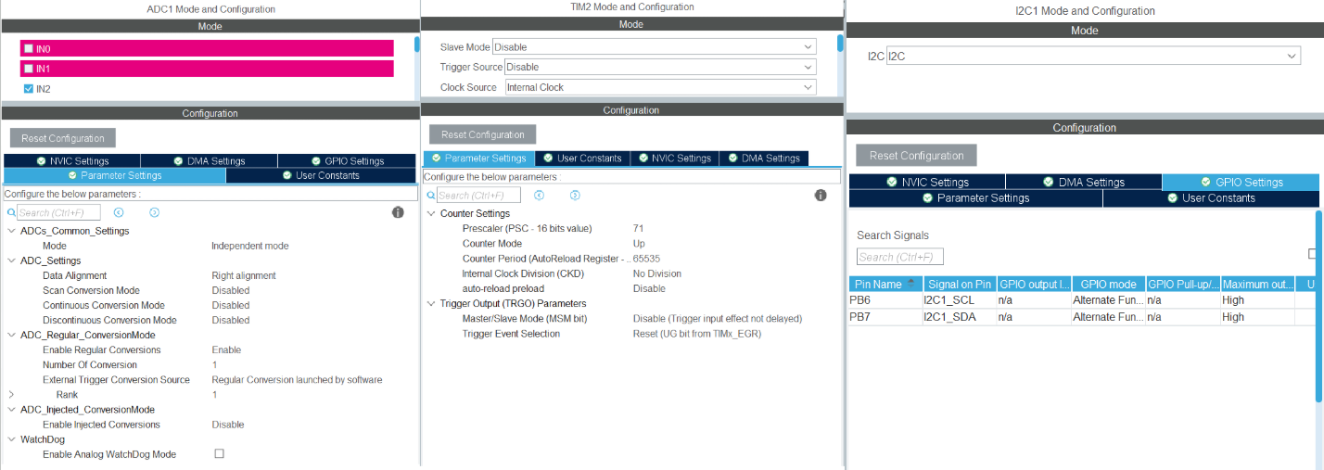
Figure 3.3 – ADC1, I²C1, and TIM2 peripheral configuration

3.4. Soil Moisture Acquisition and Processing
soil_read_raw() drives PB0 HIGH, waits 15 ms for the sensor output to settle, performs 16 ADC conversions, and computes their arithmetic mean. PB0 is then driven LOW. soil_percent(raw) converts the result to a percentage using the dry and wet calibration points stored in the configuration.
HAL_GPIO_WritePin(GPIOB, GPIO_PIN_0, GPIO_PIN_SET);
HAL_Delay(15);
for (uint8_t i = 0; i < 16; i++) {
HAL_ADC_Start(&hadc1);
HAL_ADC_PollForConversion(&hadc1, 10);
sum += HAL_ADC_GetValue(&hadc1);
HAL_ADC_Stop(&hadc1);
}
HAL_GPIO_WritePin(GPIOB, GPIO_PIN_0, GPIO_PIN_RESET);

The main loop calls this routine every 500 ms. For calibration, users navigate to “Calib KHO” or “Calib UOT” and press UP to store the current raw measurement as the corresponding calibration value. For meaningful results, the probe should be measured under stable dry and wet conditions using the same measurement setup as in practice; default values should not be assumed to fit every soil type.
static uint16_t soil_read_raw(void)
{
uint32_t sum = 0;
HAL_GPIO_WritePin(SOIL_PWR_PORT, SOIL_PWR_PIN, GPIO_PIN_SET); /* enable sensor power */
HAL_Delay(SOIL_SETTLE_MS);
for (uint8_t i = 0; i < 16; i++)
{
HAL_ADC_Start(&hadc1);
HAL_ADC_PollForConversion(&hadc1, 10);
sum += HAL_ADC_GetValue(&hadc1);
HAL_ADC_Stop(&hadc1);
}
HAL_GPIO_WritePin(SOIL_PWR_PORT, SOIL_PWR_PIN, GPIO_PIN_RESET); /* disable power to limit corrosion */
return (uint16_t)(sum / 16);
}
/* Convert to %: dry -> 0%, wet -> 100% (also handles reversed sensor polarity) */
static uint8_t soil_percent(uint16_t raw)
{
int32_t span = (int32_t)cfg.wet - (int32_t)cfg.dry;
if (span == 0) return 0;
int32_t p = ((int32_t)raw - (int32_t)cfg.dry) * 100 / span;
if (p < 0) p = 0;
if (p > 100) p = 100;
return (uint8_t)p;
}
Figure 3.4 – Soil moisture processing and conversion code
ADC values and calibration points are displayed on the LCD for monitoring. Measurement errors may arise from the AO signal path, power supply, electrode condition, or calibration procedure and can therefore affect the automatic watering decision.

3.5. DHT11, DS3231, and LCD Interface Processing
For the DHT11, DHT11_Read() drives DATA LOW for 20 ms to initiate communication, switches the pin from output to input, waits for response pulses, and decodes 40 bits. It distinguishes data levels after approximately 40 µs and validates the checksum byte. Failed updates set g_dht_ok = 0 instead of being accepted as valid readings.
For the RTC, rtc_read() calls HAL_I2C_Mem_Read() to read seven bytes starting at register 0x00 of the DS3231. bcd2dec() converts BCD data to decimal, while rtc_init_if_needed() checks the time and initializes it if the data is invalid. The DS3231 supplies the real-time information needed for scheduled watering.
The LCD user interface uses lcd_init(), lcd_send(), lcd_line(), and ui_draw(). It contains a Home page and nine configuration pages: Auto, Start, Stop, schedule enable/disable, hour, minute, pump duration, dry calibration, and wet calibration. Each display line is padded to 16 characters to erase any previous content.
static uint8_t DHT11_Read(uint8_t *temp, uint8_t *hum)
{
uint8_t data[5] = {0};
uint8_t ok = 1;
DHT11_SetOutput();
HAL_GPIO_WritePin(DHT11_GPIO_Port, DHT11_Pin, GPIO_PIN_RESET);
HAL_Delay(20);
HAL_GPIO_WritePin(DHT11_GPIO_Port, DHT11_Pin, GPIO_PIN_SET);
delay_us(30);
DHT11_SetInput();
__disable_irq();
if (!DHT11_Wait(GPIO_PIN_RESET, 100)) ok = 0;
if (ok && !DHT11_Wait(GPIO_PIN_SET, 100)) ok = 0;
if (ok && !DHT11_Wait(GPIO_PIN_RESET, 100)) ok = 0;
for (uint8_t i = 0; ok && i < 40; i++)
{
if (!DHT11_Wait(GPIO_PIN_SET, 100)) { ok = 0; break; }
delay_us(40);
if (HAL_GPIO_ReadPin(DHT11_GPIO_Port, DHT11_Pin) == GPIO_PIN_SET)
data[i / 8] |= (uint8_t)(1 << (7 - (i % 8)));
if (!DHT11_Wait(GPIO_PIN_RESET, 100)) { ok = 0; break; }
}
__enable_irq();
DHT11_SetOutput();
HAL_GPIO_WritePin(DHT11_GPIO_Port, DHT11_Pin, GPIO_PIN_SET);
if (!ok) return 0;
if ((uint8_t)(data[0] + data[1] + data[2] + data[3]) != data[4]) return 0;
*hum = data[0];
*temp = data[2];
return 1;
}
static uint8_t rtc_read(RtcTime_t *t, uint8_t *halted)
{
uint8_t b[7];
if (HAL_I2C_Mem_Read(&hi2c1, RTC_ADDR, 0x00, I2C_MEMADD_SIZE_8BIT, b, 7, 100) != HAL_OK)
return 0;
*halted = (b[0] & 0x80) ? 1 : 0; /* CH bit of the DS1307 */
t->sec = bcd2dec(b[0] & 0x7F);
t->min = bcd2dec(b[1] & 0x7F);
t->hour = bcd2dec(b[2] & 0x3F);
t->day = bcd2dec(b[4] & 0x3F);
t->month = bcd2dec(b[5] & 0x1F);
t->year = bcd2dec(b[6]);
return 1;
}
Figure 3.5 – Code for DHT11, RTC, and LCD interface processing

3.6. Pump Control Algorithm
A control cycle runs every second to evaluate automatic watering conditions and the configured schedule. With auto_en enabled, if soil moisture is below start and the cooldown has expired, auto_run is set to 1. When soil moisture reaches stop, auto_run is cleared. If an automatic watering cycle lasts 60 seconds without reaching the desired moisture level, the firmware stops the cycle and starts a five-minute cooldown.
Scheduled watering uses pump_timed and the pump_timed_end timestamp. When RTC time matches the schedule, the pump runs for pump_s seconds; by default, this is 07:00 for ten seconds. The PUMP button creates or cancels a timed watering request. The relay turns on whenever pump_timed or auto_run is true; therefore, canceling manual watering does not stop the pump if automatic watering is still requested.
if (!auto_run && g_soil < cfg.start &&
(int32_t)(tick - auto_cool_until) >= 0) {
auto_run = 1; auto_run_start = tick;
}
if (auto_run && g_soil >= cfg.stop) auto_run = 0;
relay_set((uint8_t)(pump_timed || auto_run));

if (tick - t_1s >= 1000)
{
t_1s = tick;
g_rtc_ok = rtc_read(&g_now, &halted);
if (!g_rtc_ok) lcd_err = 1; /* I2C bus error -> recovery will be attempted */
/* 1) Automatic watering based on soil moisture */
if (cfg.auto_en)
{
if (!auto_run)
{
if (g_soil < cfg.start && (int32_t)(tick - auto_cool_until) >= 0)
{
auto_run = 1;
auto_run_start = tick;
}
}
else
{
if (g_soil >= cfg.stop)
{
auto_run = 0; /* moisture sufficient -> stop */
}
else if ((tick - auto_run_start) >= AUTO_MAX_RUN_MS)
{
auto_run = 0; /* pump timed out -> cooldown */
auto_cool_until = tick + AUTO_COOL_MS;
}
}
}
else
{
auto_run = 0;
}
/* 2) Schedule: at configured time pump for pump_s seconds (trigger only once per minute) */
if (g_rtc_ok && cfg.sched_en &&
g_now.hour == cfg.sched_h && g_now.min == cfg.sched_m)
{
uint32_t key = (uint32_t)g_now.month * 100000UL + (uint32_t)g_now.day * 1440UL
+ (uint32_t)g_now.hour * 60UL + g_now.min;
if (key != sched_last_key)
{
sched_last_key = key;
pump_start_timed();
}
}
HAL_GPIO_TogglePin(LED_GPIO_Port, LED_Pin); /* blinking LED indicates program activity */
redraw = 1;
}
/* ---------- MANUAL / SCHEDULED PUMP TIMEOUT ---------- */
if (pump_timed && (int32_t)(tick - pump_timed_end) >= 0) pump_timed = 0;
/* ---------- RELAY CONTROL ---------- */
relay_set((uint8_t)(pump_timed || auto_run));
Figure 3.6 – Pump control algorithm code

3.6.1. Configuration Mechanism
MENU cycles through the configuration pages, and UP/DOWN change parameter values. A 30 ms debounce interval prevents repeated button detection. Holding UP/DOWN activates auto-repeat after 600 ms, followed by one change every 120 ms. Modified configuration values are saved to Flash when the user exits the menu or after 30 seconds of inactivity.

3.7. Flow Diagram
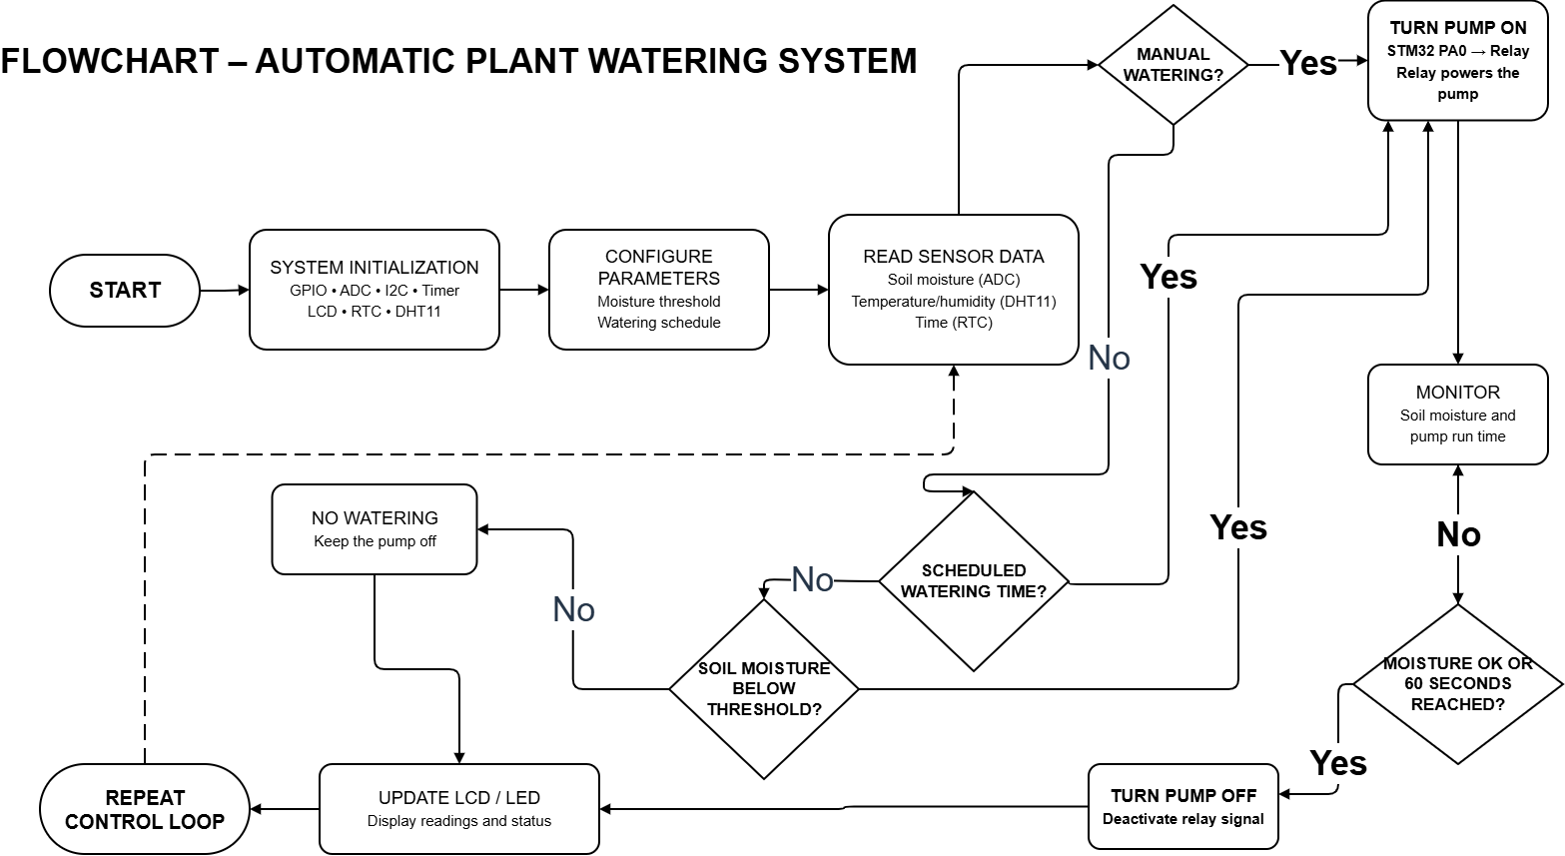

3.8. Stability and Protection Mechanisms

3.8.1. Watering Runtime Limit
Sensor-based watering is limited to 60 seconds per cycle, followed by a 300-second cooldown if the time limit is reached before the stop threshold. This mechanism reduces the risk of prolonged pumping. However, the system has no water-level sensor and therefore cannot directly detect operation with an empty tank.

3.8.2. Watchdog and I²C Recovery
Following initialization, the firmware enables an independent watchdog with an approximately four-second timeout and refreshes it continuously inside while(1). If the program remains stalled for too long, the MCU restarts. The i2c_recover() routine generates SCL pulses to release the bus and then reinitializes I²C1. The LCD is reinitialized after relay state changes, on detected errors, or every 30 seconds. These measures aim to reduce electrical interference associated with relay switching.

3.8.3. Saving Parameters to Flash
The Config_t structure stores the automatic-mode state, two moisture thresholds, watering schedule, pump duration, and calibration points. The firmware uses Flash address 0x0800FC00 to save the configuration, corresponding to the final page on a microcontroller with 64 KB of Flash. This design depends on the actual Flash capacity and memory regions used by the program; excessively frequent writes can also reduce memory endurance.
static void cfg_load(void)
{
memcpy(&cfg, (const void *)CFG_ADDR, sizeof(cfg));
if (cfg.magic != CFG_MAGIC || cfg.start > 95 || cfg.stop > 100 || cfg.start + 5 > cfg.stop ||
cfg.sched_h > 23 || cfg.sched_m > 59 || cfg.pump_s < 1 || cfg.pump_s > 120 ||
cfg.auto_en > 1 || cfg.sched_en > 1 || cfg.dry > 4095 || cfg.wet > 4095)
{
cfg_default();
}
}
static void cfg_save(void)
{
FLASH_EraseInitTypeDef e;
uint32_t err = 0;
const uint16_t *p = (const uint16_t *)&cfg;
cfg.magic = CFG_MAGIC;
HAL_FLASH_Unlock();
e.TypeErase = FLASH_TYPEERASE_PAGES;
e.PageAddress = CFG_ADDR;
e.NbPages = 1;
if (HAL_FLASHEx_Erase(&e, &err) == HAL_OK)
{
for (uint8_t i = 0; i < sizeof(cfg) / 2; i++)
HAL_FLASH_Program(FLASH_TYPEPROGRAM_HALFWORD, CFG_ADDR + 2U * i, p[i]);
}
HAL_FLASH_Lock();
cfg_dirty = 0;
}
/* Independent watchdog (~4 seconds): automatically reset if firmware stalls */
DBGMCU->CR |= DBGMCU_CR_DBG_IWDG_STOP; /* pause watchdog during debugging */
IWDG->KR = 0xCCCC; /* enable watchdog */
IWDG->KR = 0x5555; /* allow PR and RLR writes */
IWDG->PR = 4; /* divide by 64 -> 625 Hz */
IWDG->RLR = 2500; /* 2500 / 625 = 4 seconds */
for (uint32_t i = 0; IWDG->SR != 0 && i < 100000UL; i++) { }
IWDG->KR = 0xAAAA;
Figure 3.7 – Configuration storage and error-handling code
Software protection mechanisms do not replace the system’s electrical safety requirements. Pump power and relay ratings must be appropriate for the load; connections must be insulated, protected from water, and designed to reduce noise or switching transients.

CHAPTER 4. TESTING AND EVALUATION

4.1. Test Objectives and Methodology
The test cases were designed to evaluate the wiring and operation of each function. Recorded indicators include soil moisture, RTC time, relay and pump states, LCD content, and response time. Results are compared with the design requirements to evaluate system performance.
ID | Test condition | Expected result | Actual result
T1 | Soil below Start threshold | Pump ON if auto is enabled and cooldown is inactive | As expected
T2 | Soil reaches/exceeds Stop threshold | End the automatic pumping request | As expected
T3 | Soil remains dry for >60 s | Automatic mode enters a 300 s cooldown | As expected
T4 | RTC reaches the scheduled time | Pump runs for pump_s seconds | As expected
T5 | Press PUMP button | Start/stop timed pumping request | As expected
T6 | Change configuration + reset | Configuration restored from Flash | As expected
T7 | DHT11 disconnected | Display “--” for T/RH | As expected
T8 | LCD / I²C communication failure | Attempt bus and LCD recovery | As expected

Table 4.1. Functional test scenarios. When assessing the 300-second cooldown, sensor-controlled pumping must be distinguished from scheduled or manual pumping requests.
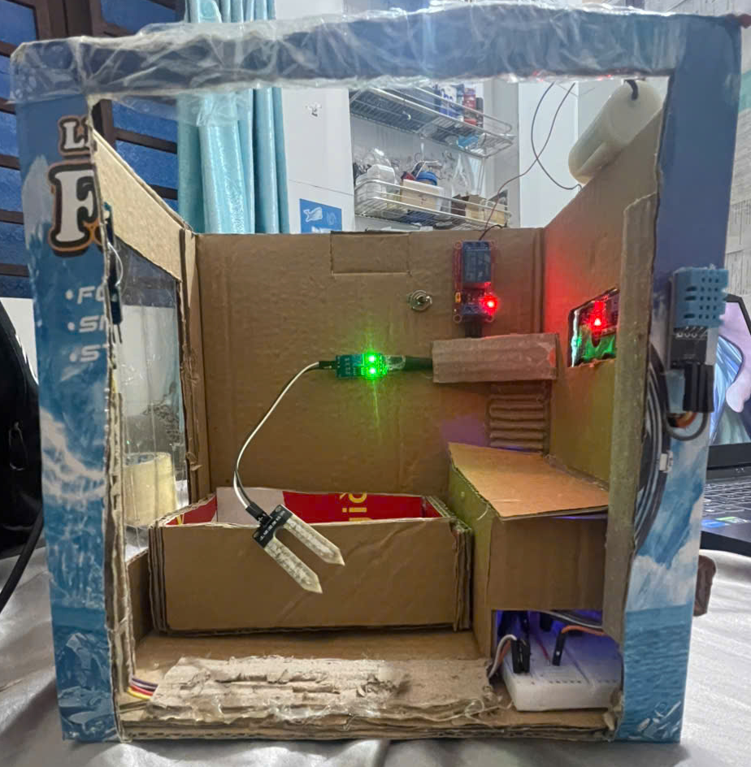
Figure 4.1 – Automatic plant watering system prototype

4.2. Experimental Data and Photographs
The experimental table records raw ADC values, converted soil moisture, RTC time, and pump state under different test conditions. Displayed soil moisture percentages are relative values derived from two calibration points rather than standardized volumetric water content measurements.
Measurement | ADC raw | Moisture (%) | RTC time | Pump state | Notes
1 | [3800 ] | [8 ] | [14:05:12 ] | [ON] | [Dry soil, automatic pump ON]
2 | [2000 ] | [80 ] | [14:07:40 ] | [OFF] | [Just watered, soil is wet]
3 | [2400 ] | [64 ] | [14:12:25 ] | [OFF] | [Soil gradually drying after a few minutes]
4 | [2800 ] | [48 ] | [14:15:03 ] | [ON] | [Manual pumping for 10 seconds (PUMP button)]

Table 4.2. Experimental data recording sheet.
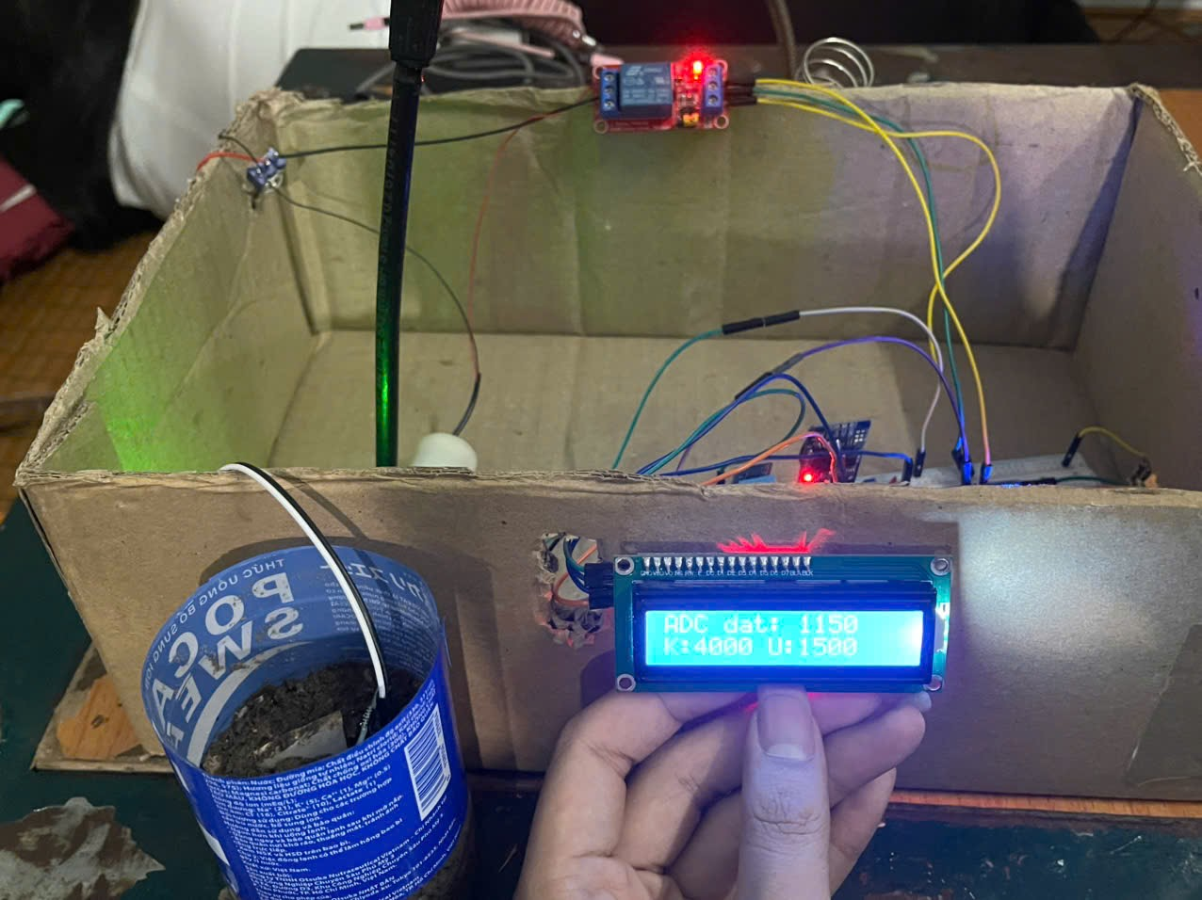
Figure 4.2 – Dry soil condition with the pump operating
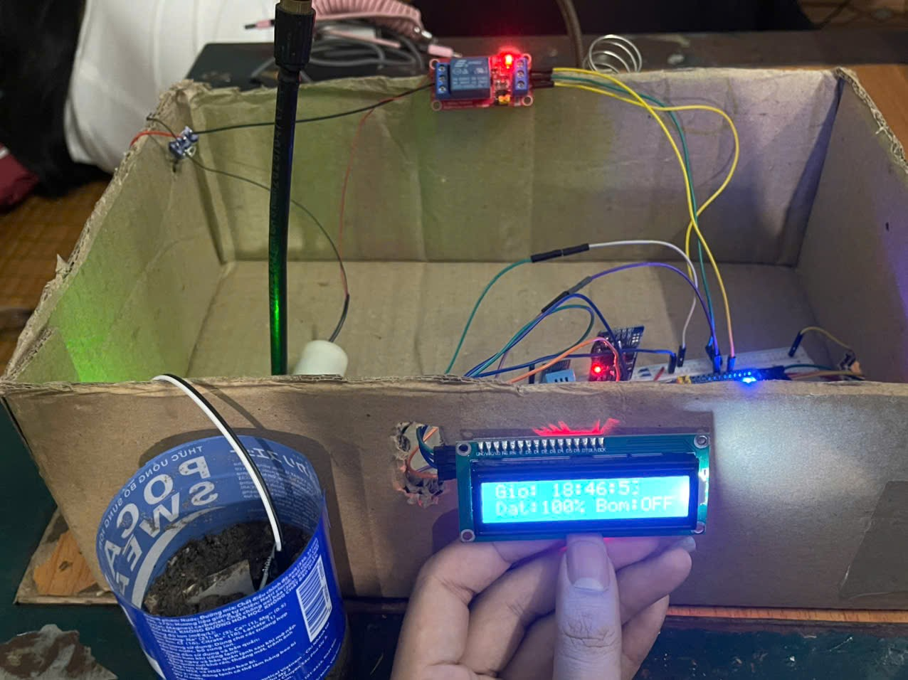
Figure 4.3 – Adequately moist soil or scheduled watering

4.3. Evaluation of Experimental Results
The test scenarios in Table 4.1 indicate that the system met the specified requirements for the functions examined, including moisture-based automatic watering, scheduled watering, manual control, configuration storage, and handling of selected error conditions.
The results in Table 4.2 show changes in soil moisture corresponding to the raw ADC readings. At 8% moisture, the pump was switched on automatically. After watering, moisture increased to 80%, and the pump switched off. In the final measurement, the pump was activated manually while soil moisture was 48%.
Overall, the recorded results indicate that the system performed its intended control functions under the tested conditions. However, the team has not assessed continuous long-term operation and therefore cannot draw comprehensive conclusions about durability or long-term stability.

CHAPTER 5. CONCLUSIONS AND FUTURE DEVELOPMENT

5.1. Conclusions
This project developed control firmware for an automatic plant watering system using the STM32 Blue Pill as the central processor. The design integrates a soil moisture sensor, DHT11, DS3231 RTC, I²C LCD 1602, relay, and submersible pump. The software supports two-threshold moisture-based watering, scheduled watering, and manual watering requests, while incorporating calibration, Flash configuration storage, an automatic watering runtime limit, a watchdog, and I²C recovery.
Through this project, the team applied microcontroller programming, peripheral communication, and sensor-signal processing knowledge to design a small-scale watering system. Assessments of accuracy, stability, and practical operation are based on test results rather than inferred solely from the source code.

5.2. Limitations and Challenges
- Soil moisture is expressed as a relative value based on two calibration points and is influenced by soil material, probe location, electrode corrosion, and power-supply stability.
- The DHT11 is used only for monitoring; no algorithm currently adjusts watering according to weather or the needs of individual plant species.
- The system does not include water-level or flow sensors, dry-run detection, or a sensor confirming that the relay has changed state.
- The modules operate at different voltage levels, so compatibility among power supplies, control signals, and the relay must be ensured. Furthermore, the prototype has not been thoroughly evaluated for durability or extended continuous operation.
- The ADC acquisition routine currently does not verify conversion completion before using the acquired data. If a measurement fails, the control algorithm has no dedicated mechanism for disabling watering decisions based on invalid readings.
- When the dry and wet calibration values are equal, the conversion function returns 0%. This is an invalid calibration condition but is not yet handled as a separate warning.
- If the LCD does not respond immediately during startup, the firmware enters an LED-based error indication mode before enabling the watchdog. Consequently, the watchdog cannot recover from this situation.

5.3. Future Development
In the future, the team could improve the system to make it more reliable and convenient in practical use. First, the resistive soil moisture sensor could be replaced with a capacitive sensor to reduce corrosion and extend sensor life. Adding a water-level sensor would also help detect a nearly empty reservoir and reduce the risk of running the pump without water.
At the software level, the team could add error alerts, watering-history logging, and watering-time adjustments tailored to plant species. The system could also be extended with Wi-Fi or Bluetooth connectivity to allow users to monitor status and change watering schedules remotely using a phone.
For multiple pots or growing areas, the design could be expanded into independent watering zones, each with an appropriate sensor and pump controller. These improvements would require testing for accuracy, electrical safety, and long-term operation before practical deployment.

REFERENCES
[1]
X. Xie and W. Jiang, “An Automatic System Design for Orchard Irrigation Based on STM32 and Zigbee Technology,” rjaset, vol. 13, no. 6, pp. 503–509, Sep. 2016, doi: 10.19026/rjaset.13.3010.

[2]
- V. Cong and N. T. H. Trang, “Design and Implement of a smart garden system using STM32 microcontroller”.

[3]
- Li Yunhan Li, “Design of Intelligent Watering Robot Based on STM32,” IJSR, vol. 12, no. 5, pp. 188–193, May 2023, doi: 10.21275/SR23501183712.

[4]
“STM32-based IoT Monitoring System for an Indoor Plant.”

